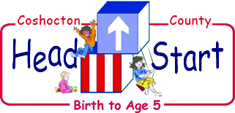

Annual Report
2021/2022

Submitted by: Susan Craddock
Executive Director

Our Mission
“Coshocton County Head Start Inc. is a comprehensive family and child development program committed to providing quality services that support and nurture the families we serve. Our work connects through our community as we prepare our children for a successful future, in doing so we benefit not only our families, but our broader community as well”

Introduction
Coshocton County Head Start, Inc. serves families and children ages Birth-5 through an
integrated delivery model. CCHS currently is funded for 202 children and their families.
We serve 146 children in our Head Start program (ages 3-5) across three sites: South
Lawn, Hill top and Coshocton County Career Center.
We are also funded for 56 children in our Early Head Start program (ages 0-3) including 24
home based Children/up to 4 pregnant mothers.

Coshocton County Head Start, Inc. Proposed Service Area
The county is made up of 22 townships with Coshocton County Head Start serving fifteen of these townships located in the eastern and central portion of the county. Kno-Ho-Co CAC serves the western portion of the county. Our Early Head Start program includes all 22 townships. The five villages found in Coshocton County include: Conesville, Nellie, Plainfield, Warsaw, and West Lafayette.
Community Snapshot
Employment Expo: September 22, 2022
- Ohio Means Jobs of Coshocton County held its annual employment expo on Thursday at Lake Park Pavilion with 46 employers.
- OMJ routinely has more than 200 full-time and part-time jobs available locally with healthcare and manufacturing most in need of workers.
- The COVID-19 pandemic offset the workforce and it hasn't righted yet with many Baby Boomers and women deciding to stay home.
- Local employers looking for workers and the positions they have open run the gamut with finding those with the skill sets a major obstacle.
Child Wefare cases in Coshocton County:
- Foster Care: 20 Children under the age of 6
- Kinship Care: 10 children under 6
- SNAP Benefits: 557 kids under 6

Monthly enrollment by Program
Month/Year | Preschool | Infant/Toddler
November 2021 | 112 | 50
December 2021 | 110 | 48
January 2022 | 102 | 45
February 2022 | 99 | 46
March 2022 | 96 | 45
April 2022 | 103 | 46
May 2022 | 104 | 48
June 2022 | 96 | 48
July 2022 | 0 | 47
August 2022 | 0 | 48

Program Monitoring
Office of Head Start Reviews: The Office of Head Start conducted a Focus Area One monitoring review during the week of March 7 to March 11, 2022. The results of the Focus Area One monitoring review showed no Areas of Concern, Areas of Noncompliance or Deficiencies.

Annual Audit:
Coshocton County Head Start, Inc. is a 501(c)(3) Non-Profit organization. ZENO, POCKL, LILLY and COPELAND, A.C. Certified Public Accountants conducted our 2021 audit which is a requirement from Uniform Guidance (75.501) by the Government Publishing Office. The auditors check 100% of all Payroll, Account Payable and Deposit transactions. Coshocton County Head Start, Inc. had no findings in this audit.
Coshocton County Head Start is currently in the process of the 2021-2022 audit. This is being conducted by: ZENO, POCKL, LILLY and COPELAND, A.C. Certified Public Accountants.
When this audit is complete updates can be found on our Website.

Our Financials

Coshocton County Head Start and our local community benefit from federal funding to support Head Start preschool services to 146 children and families, Early Head Start services for 56 pregnant moms, infants, toddlers and their families, and Early Childhood Education for 29 children and families. Funding is based on the 202 available slots; the actual number of children and pregnant moms served in 2021-22 was 217.
2021-2022 Funding by Revenue Source: $ 4,152,065
Federal Head Start | $1,695,496 | Capital Campaign Donations | $10,100
Federal Early Head Start | $1,053,407 | USDA | $76,772
American Rescue Plan Funding | $241,693 | Ohio Childcare Stabilization Grant | $174,000
Early Childhood Education (State Funding) | $152,000 | Non-Federal Match (In-kind) | $796,881

2021-2022 EXPENSES: $2,643,622 2022-23 FEDERAL BUDGET: $2,748,903
 | HEAD START | EARLY HEAD START | EARLY CHILDHOOD EDUCATION | TOTAL
SALARIES | $1,030,945 | $664,593 | $85,575 | $1,781,113
FRINGES | $275,442 | $189,564 | $14,050 | $479,056
TRAVEL | $3,761 | $4,982 | $0 | $8,743
SUPPLIES | $49,550 | $35,850 | $0 | $85,400
OTHER | $335,798 | $158,418 | $52,375 | $546,591
ESTIMATED FUNDING | $1,695,496 | $1,053,407 | $152,000 | $2,900,903
IN-KIND | $423,874 | $263,352 | ----------- | $687,226
TOTAL | $2,119,370 | $1,316,759 | $152,000 | $3,588,129

*Other expenses include: volunteer costs, parent services, publications/advertising/printing, staff costs (including advertising and pre-employment screenings), training and staff development (including college coursework), insurances (bonding, directors’ and officers’ liability, and general liability), and interest expense.
*Non-Federal Match (IN-KIND) is a requirement that we must match 25% of our annual grant revenue with volunteers, donated services, and/or space cost valuation.

School Readiness
The Head Start Approach to School Readiness means that children are ready for school, families are ready to support their children's learning, and schools are ready for children.
Head Start views school readiness as children possessing the skills, knowledge, and attitudes necessary for success in school and for later learning and life. Physical, cognitive, social, and emotional development are all essential ingredients of school readiness.

Coshocton County Head Start School Readiness Plan includes:
School Readiness Team School Readiness Goals Staff Development Family Engagement Evaluating Child Outcomes Supporting Transitions High Quality Teaching and Learning Relationships with Community Partners

Curriculum
Infant-Toddler High Scope Curriculum: Teachers focus on developing supportive, trusting relationships with the children in their care. We create rich environments that encourage very young children to explore and discover the world around them, helping them to engage in experiences designed to support their optimal development in all domains.
High Scope Preschool Curriculum: Play-based, child-centered, and grounded in research, the High Scope Curriculum features active learning at its core. In a High Scope classroom, children are guided to explore, interact, and exercise their creative imagination through purposeful play. Well-prepared teachers support and extend each child’s learning based on their developmental levels, so children enter school ready and eager to learn.
Early Head Start Home Based Curriculum: Partners for a Healthy Baby researched based curriculum addresses a wide range of topics including: improved prenatal health; healthy birth outcomes; bonding and attachment; positive parenting; enhanced child health and development; infant mental health; economic self-sufficiency; and family stability.

Preschool Outcomes Data
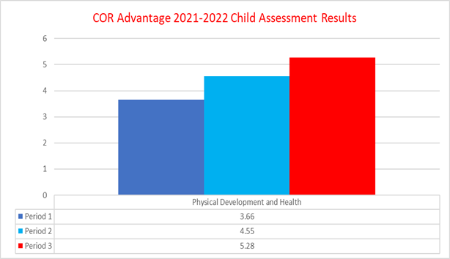
Cor. Advantage-The 2021/2022 child assessment outcomes showed progression in all areas. In continuation from the previous year, Physical Development and Health remained one of our highest scores. Within this category Personal care and healthy behavior, Gross motor skills and Fine motor skills remain at high scoring levels. At the end of the school year an average score of 5.28 was achieved with a gain of 1.62. Over 50% of our preschool students scored within the top two levels in this category. 80% of students were meeting or above the National average.
CLASS- The Head Start classroom teachers continue to produce high level scores from the CLASS observation in the domains of Emotional Support and Classroom Organization. We remain above the National average and had increased scores from the previous year in all three domains. We have had additional training this school year from STG on the CLASS tool to help increase the teacher’s knowledge and skills in adult / child interactions.
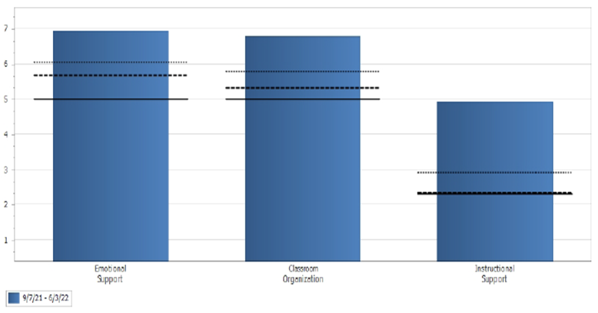
Coshocton County Head Start, Inc. 5630 - Pre-K CLASS® Average Score Charts.
Observations occurring: 9/7/2021 - 6/3/2022

Early Head Start Outcomes Data

High Scope’s COR Advantage assessment: assesses early childhood development through kindergarten in 8 areas. In the table below, you will find that the EHS program has shown a consistent increase in scores in all 8 areas for the first 3 periods of the 2021-2022 school year. Physical Development continues to be the top-ranking area at 2.38 EHS. This continued growth can be related to the ages of the children in the classroom; age group 6 mos. to 3 years (Home Base birth to 3 years). Many of the children were just beginning to stand and some were at the beginning stages of walking. Approaches to Learning ranked the second highest over the first three periods this year with a score of 2.03. Mathematics had the lowest ranking at 1.8. The staff spent time with our TA/A Specialist discussing what “mathematics” meant for infants and toddlers. The information received demonstrates that they are beginning to see what constitutes a mathematical achievement for Infant/Toddlers by the increase from 1.19 to 1.80.

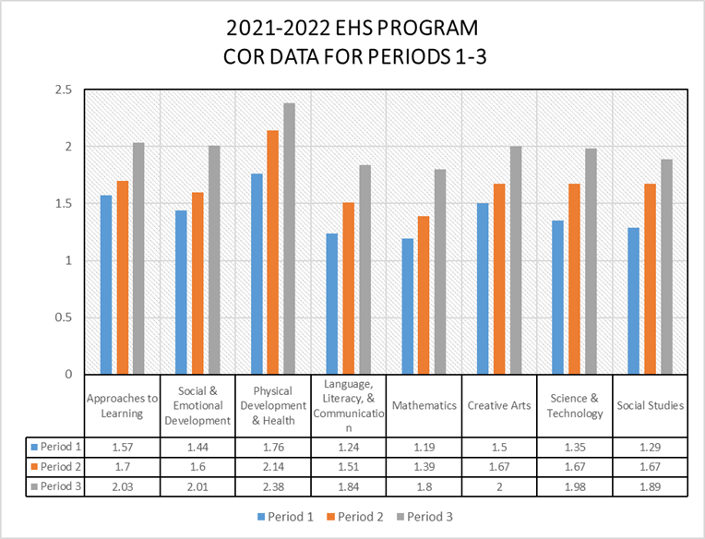

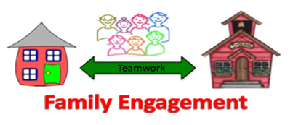
As their child’s first and most influential teacher, parents have an important role in Head Start. Parents are always welcome in the classroom by helping with or leading activities, attending learning trips, planning classroom activities with the teaching staff, and introducing or sharing their culture with the children. There are a number of ways that parents can help teaching staff by sharing opinions, ideas and thoughts, working on activities at home, communicating with the staff, helping other parents feel welcome, and reinforcing learning at home.
In addition, Coshocton County Head Start offers parents the opportunity to participate in the following activities:
Family Literacy Activities Parent Committee Meetings
Volunteering Training
Input into Program Planning Resource and Referral Information
Recruitment Parent/Teacher Conferences / Home Visits
Family Partnership Agreements Input into the Curriculum

Parent Curriculum

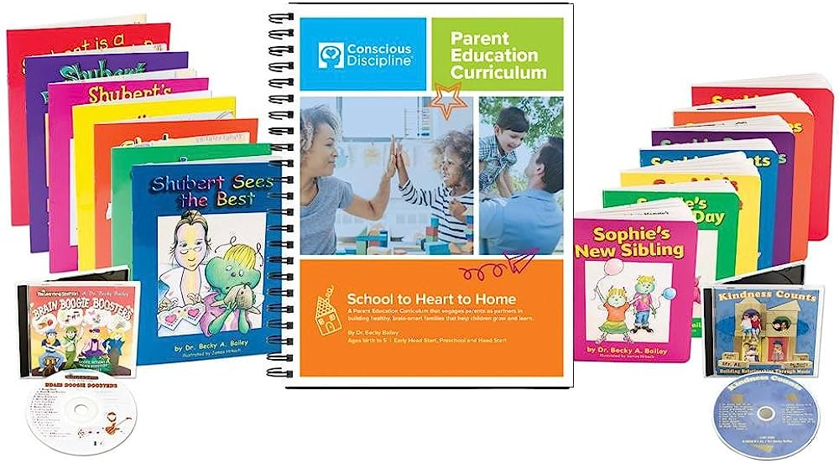

2021 – 2022 Impacts

Served 128 children below 100% of the federal poverty line
Number of Employees:
52
Served 16 Homeless Children.
6 children in foster or kinship care

205 Children up to date on Immunizations

205 Children received a Physical
Served 18 Children with IFSP’s and 15 Children with IEP’s

183 Children received a Dental Exam

